PARKINSON’S TREMOR DETECTION SYSTEM
by
HARI SAI SENTHIL KUMAR
Roll No: 24BLC1108
ANIRUDHAN
Roll No: 24BLC1335
A project report submitted to
Dr. GUGAPRIYA
SCHOOL OF ELECTRONICS ENGINEERING
in partial fulfilment of the requirements for the course of
BECE204L – MICROPROCESSORS AND MICROCONTROLLERS
B.Tech. ELECTRONICS AND COMMUNICATION ENGINEERING


Vandalur – Kelambakkam Road
Chennai – 600127
NOVEMBER 2025

BONAFIDE CERTIFICATE

Certified that this project report entitled “PARKINSON’S TREMOR DETECTION SYSTEM” is a bonafide work of HARI SAI SENTHIL KUMAR (24BLC1108) and ANIRUTHAN (24BLC1335), who carried out the project work under my supervision and guidance for BECE204L – MICROPROCESSORS AND MICROCONTROLLERS.
Dr. GUGAPRIYA
Associate Professor
School of Electronics Engineering (SENSE)
VIT Chennai

ABSTRACT
Parkinson’s disease is a neurological disorder characterized by involuntary tremors. This project focuses on detecting tremors within the frequency range of 4–6 Hz using an MPU6050 sensor and ESP-32. The gyroscope data from MPU6050 is processed using the Fast Fourier Transform (FFT) algorithm to identify dominant frequencies. If the measured frequency lies between 4–6 Hz and exceeds a certain threshold, the system flags it as a tremor. This low-cost, real-time detection system can assist in monitoring tremor activity and potentially aid in Parkinson’s diagnosis and treatment monitoring.

MATERIALS USED
• ESP32 Dev Module
• MPU6050 Sensor Module
• Connecting Wires
• Breadboard
• USB Cable
• Buzzer
• LCD Display

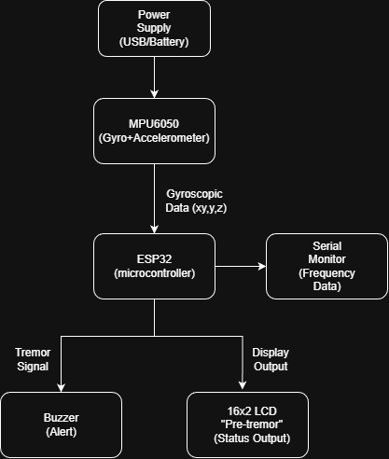
BLOCK DIAGRAM

CIRCUIT DIAGRAM
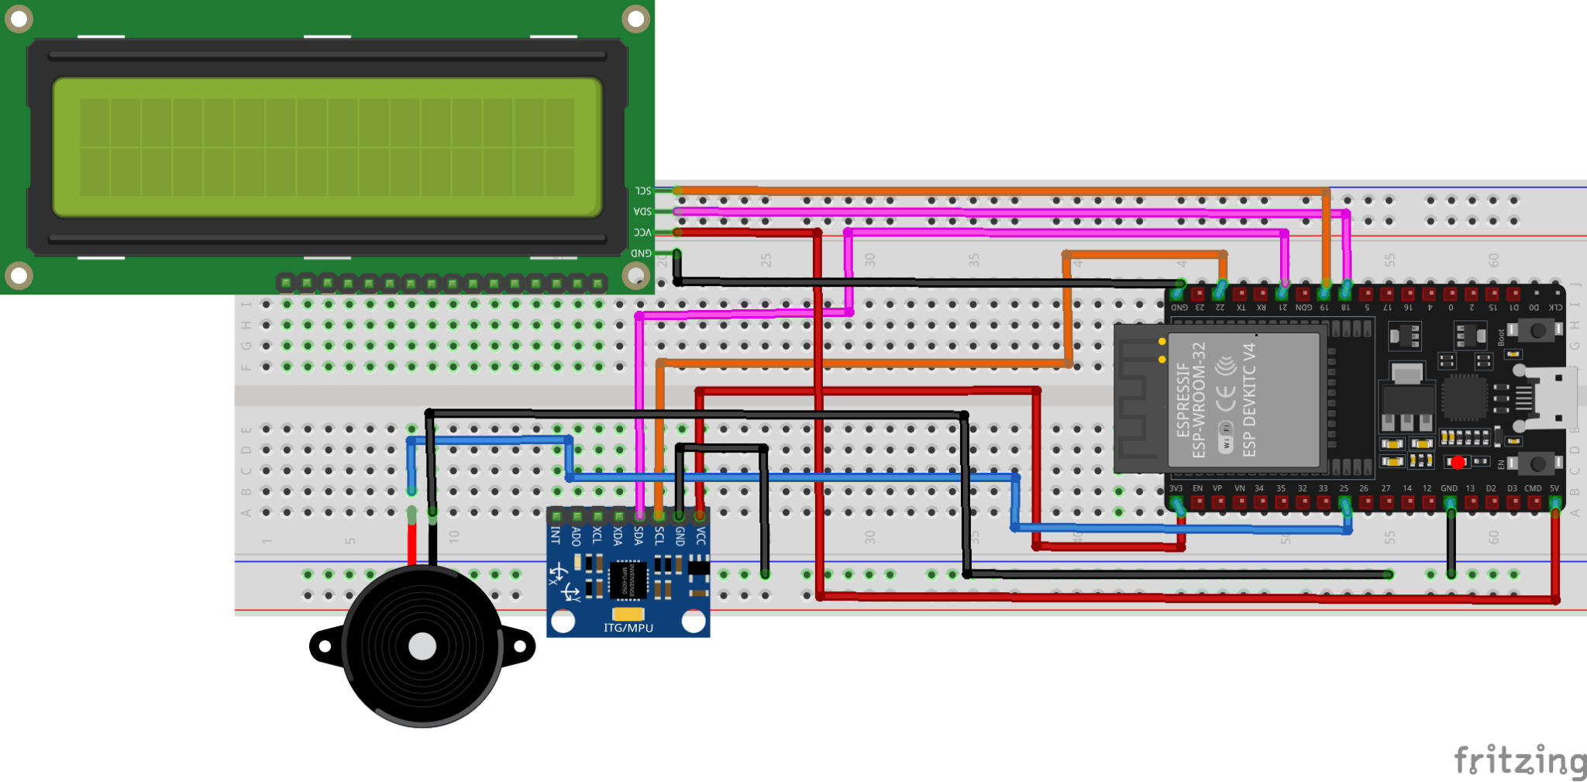

WORKING PRINCIPLE
- The MPU6050 sensor captures hand motion data in the form of angular velocity along the X, Y, and Z axes.
- The ESP32 microcontroller continuously samples 128 gyroscopic readings at a rate of 100 Hz.
- The collected time-domain data is processed using Fast Fourier Transform (FFT) to convert it into the frequency domain.
The dominant frequency component of the motion is identified from the FFT output.
- If the dominant frequency lies within the 4–6 Hz range and the magnitude exceeds a predefined threshold, the system classifies the motion as a tremor event.
- The LCD display shows real-time status messages such as “Normal”, “Pre-Tremor Detected”, or “Tremor Detected” based on the analysis.
- The Serial Monitor simultaneously logs the detected frequency and tremor status, while the buzzer provides an audible alert during tremor detection.

ARDUINO CODE
#include <Wire.h>
#include <Adafruit_MPU6050.h>
#include <Adafruit_Sensor.h>
#include <arduinoFFT.h>
#include <LiquidCrystal_I2C.h>
#define BUZZER_PIN 25
#define MPU_SDA 21
#define MPU_SCL 22
#define LCD_SDA 18
#define LCD_SCL 19

Adafruit_MPU6050 mpu;
TwoWire I2CMPU = TwoWire(0);
TwoWire I2CLCD = TwoWire(1);
LiquidCrystal_I2C lcd(0x27, 16, 2);
#define SAMPLES 128
#define SAMPLING_FREQUENCY 100.0
ArduinoFFT<double> FFT = ArduinoFFT<double>();
double vReal[SAMPLES];
double vImag[SAMPLES];
#define TREMOR_MIN_HZ 4.0
#define TREMOR_MAX_HZ 6.0
#define TREMOR_THRESHOLD 10.0
unsigned long lastSampleMicros = 0;
int sampleCount = 0;
const unsigned long samplingInterval = 1000000 / SAMPLING_FREQUENCY;

void setup() {
Serial.begin(115200);
pinMode(BUZZER_PIN, OUTPUT);
ledcSetup(0, 2000, 8);
ledcAttachPin(BUZZER_PIN, 0);
ledcWrite(0, 0);
I2CMPU.begin(MPU_SDA, MPU_SCL, 100000);
I2CLCD.begin(LCD_SDA, LCD_SCL, 100000);
lcd.begin(16, 2);
lcd.backlight();
lcd.clear();
lcd.setCursor(0, 0);
lcd.print("Parkinson's Test");
lcd.setCursor(0, 1);
lcd.print("Initializing...");
delay(1500);
lcd.clear();
if (!mpu.begin(0x68, &I2CMPU)) {
Serial.println("MPU6050 not found. Check wiring!");
lcd.print("MPU Error!");
while (1);
}
Serial.println("MPU6050 Connected!");
lcd.print("MPU Ready");
delay(1000);
lcd.clear();
}
void loop() {
if (sampleCount < SAMPLES) {
if (micros() - lastSampleMicros >= samplingInterval) {
lastSampleMicros = micros();
sensors_event_t a, g, temp;
mpu.getEvent(&a, &g, &temp);
vReal[sampleCount] = g.gyro.x;
vImag[sampleCount] = 0;
sampleCount++;
}
return;
}
FFT.windowing(vReal, SAMPLES, FFT_WIN_TYP_HAMMING, FFT_FORWARD);
FFT.compute(vReal, vImag, SAMPLES, FFT_FORWARD);
FFT.complexToMagnitude(vReal, vImag, SAMPLES);
double peakFrequency = 0;
double peakMagnitude = 0;
for (int i = 1; i < (SAMPLES / 2); i++) {
double freq = (i * SAMPLING_FREQUENCY) / SAMPLES;
if (vReal[i] > peakMagnitude) {
peakMagnitude = vReal[i];
peakFrequency = freq;
}
}
Serial.print("Dominant Freq: ");
Serial.print(peakFrequency, 2);
Serial.print(" Hz | Magnitude: ");
Serial.println(peakMagnitude, 2);
if (peakFrequency >= TREMOR_MIN_HZ && peakFrequency <= TREMOR_MAX_HZ && peakMagnitude > TREMOR_THRESHOLD) {
Serial.println("Tremor Detected!");
lcd.clear();
lcd.setCursor(0, 0);
lcd.print("TREMOR DETECTED!");
ledcWriteTone(0, 2000);
} else if (peakFrequency >= TREMOR_MIN_HZ - 1 && peakFrequency <= TREMOR_MAX_HZ + 1 && peakMagnitude > (TREMOR_THRESHOLD / 2)) {
Serial.println("Pre-Tremor Detected!");
lcd.clear();
lcd.setCursor(0, 0);
lcd.print("Pre-Tremor");
lcd.setCursor(0, 1);
lcd.print("Detected");
ledcWriteTone(0, 1000);
} else {
lcd.clear();
lcd.setCursor(0, 0);
lcd.print("Normal");
ledcWriteTone(0, 0);
}
sampleCount = 0;
delay(1000);
}

CONCLUSION
The Parkinson’s Tremor Detection System successfully identifies tremors in the 4–6 Hz frequency range. Using FFT-based signal analysis, the system provides a reliable, real-time indication of tremor activity. This prototype is low-cost and suitable for further enhancement using wireless communication or machine learning.

REFERENCES

https://create.arduino.cc/projecthub/ - For programming the ESP-32 with Arduino IDE
https://www.instructables.com/ - For references to connect different components
https://components101.com/sensors/mpu6050-gyro-accelerometer-module - MPU6050 pinout and data sheet
https://www.arduino.cc/en/Reference/ArduinoFFT - For references to use Fast Fourier Transform to sample data from MPU6050 sensor
https://fritzing.org/ - To make the circuit diagram with different components

